**Application**

Refer to the Air Quality data described previously, and the analyses we have done with Ozone as the response variable, and the five explanatory variables (including the two engineered features).

1. Use GAM to model the relationship between Ozone and all five explanatories:

(a) Print out and look at the summary from the gam object.

i. **Show the summary**

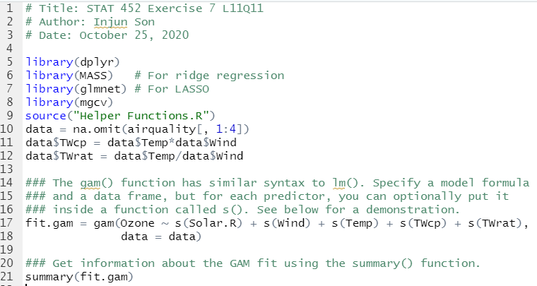

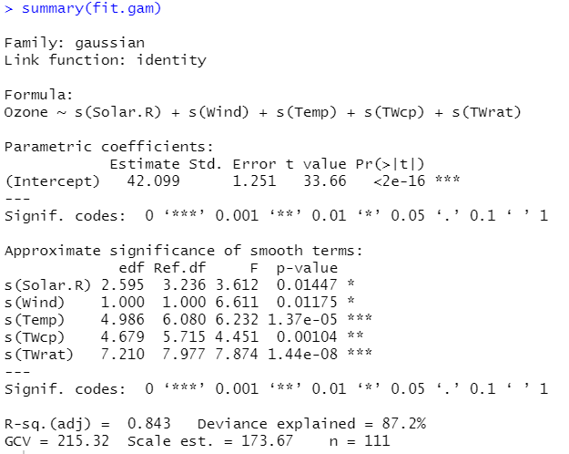

ii. **According to the summary, are there any variables that seem unimportant?**

**If so which ones?**

* No, all the p-values are lower than 0.05 which means they are significant.

iii. Which variables seem to have the most nonlinear influence on Ozonw, according

to their degrees of freedom?

-> TWrat has the highest edf so I guess TWrat would have the most nonlinear influence on Ozone.

(b) Plot the marginal splines for each variable, making sure that the plot is large

enough for you to see the patterns and the error bounds

1. **Present these plots.**

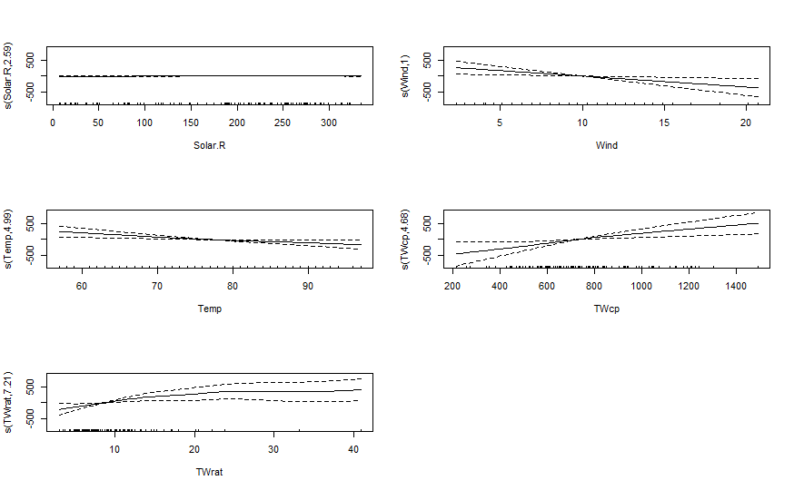 ii. For the two most nonlinear patterns identified in part (a), comment on the

shape of the patterns. **Does the nonlinearity suggest a clear nonmonotone**

**relationship, or mostly just vary the rates of increasing and decreasing trends?**

* Temp and TWrat have the highest edf, so two will be most non linear. For Temp, the nonlinearity suggests just the increasing and decreasing trends but for TWrat the nonlinearity suggests a nonmonotone relationship.